SHIVAM MANTRELU
Frontend Developer
E +91 9518705566  Shivammantrelu9@gmail.com q https://linkedin.com/in/shivam-mantrelu-a71431214 e Pune

PROFILE

Enthusiastic Front-End Developer with 1.7 year of hands-on experience. Proficient in HTML, CSS, and JavaScript, creating responsive and user- friendly websites. Strong problem-solving and collaboration skills.

EXPERIENCE

Software Engineer 11/2022 - 05/2023
GeekRabit Pune, Maharashtra,
India
Company Description
- GR Website. It was a service based company. Where I have to handle the frontend of website. This website belongs to Geekrabit Solution PVT.LTD official Web site.
  - Client can see the Project Developed by the company.
  - It has a Job & Placement Opportunity.
  - Show the technology which they are working
Web Developer | 09/2022 - 11/2022
Picpoint.in | Pune,India
Company Description
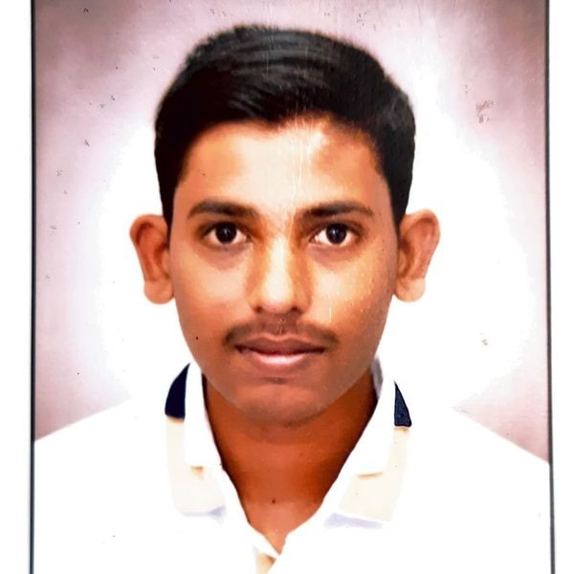
- This Project Was startup company. Started by over college student We specialize in creating stunning and immersive photography websites for companies.
SKILLS
Front-End

HTML 5
CSS 3
JavaScript
Bootstrap 5
Hostinger
Angular
Angular Material
ReactJS
Figma
Tool / Technology
CERTIFICATIONE
Full Stack Web Developer,

React JS
Our responsive designs ensure seamless viewing on all devices, showcasing your work in its full glory.
Elevate your brand with our visually captivating and user-friendly website solutions
Frontend Web Developer | 04/2022 - 09/2022
NEETA TECH PVT LTD | Pune, Maharashtra, India
Company Description
- Which of your achievements match the job you’re applying to?
Frontend Developer | 11/2021 - 02/2022
Mahavir Enterprises Pvt. Ltd. | Pune, Maharashtra, India
Company Description
- I have worked on Payroll system for 'Shintre Consultancy'. My task was to design the application. It work like to generate the payment slip of the employees. In small and mid level company 1 Generating Reports.
  - Provide Security Company.
  - Provide Security For Employees.

LANGUAGES
English
Advanced
Powered by  www.enhancv.com
12
/2021
- 07/2023
01
/2018
- 01/2021
06
/2017
- 03/2018
06
/2014
- 02/2015
Powered by
EDUCATION
Master of Computer Applications - MCA,

Computer Science. With 7.68 SGPA
JSPM's Jaywant Institute Of Management Studie.

Savitribai Phule Pune University
BCS, Computer Science. With 73.43%
Vivekananda College (Late Pandharinath Patil Institute.)

DR.BABASHEB AMBEDKAR MARATHWADA

HSC. With 70.62%
Lokmanya Tilak Jr. College Of arts And science.

Maharastra state board

SSC. With 61%
Shri MS Jain English School.

Maharashtra state board of secondary and higher secondary

education Pune.
www.enhancv.com


